# **CPS 475/575 - Secure Application Development, Spring 2020**

Dr. Phu Phung

Department of Computer Science,  
University of Dayton

Lab 4 - Client-side Web Security and Webpage Development

Announced and Instruction released: 2/25/2020 (Lecture 13)

Deadline:

Introduction

In this lab, you will do hands-on exercises on creating simple webpages with HTML and JavaScript. From the simple piece of JavaScript code, you should l understand the basic of JavaScript and client-side Web security. You will also do self-studying how to design a personal webpage using Bootstrap CSS. You will learn to deploy the webpage on bitbucket.io and Apache Web Server.

**Source code organization:** You need to push all your code for this lab under a folder labs/lab4 within your private repository (Although in this lab, you need to push into the bitbucket-username.bitbucket.io repository). You need to include the URL of this folder at the beginning of your report. For example, in my case, the URL is:  
[https://bitbucket.org/phu-udayton/secad-pphung1/src/master/labs/lab4/](https://bitbucket.org/phu-udayton/secad-pphung1/src/master/labs/lab3/)

**You will lose 5% of this lab grade if this URL is missing in your report and 5% if the code is not in your repository.**

This lab has two tasks with 30 points:

Task 1 (20 points): Simple Webpage Development & Deployment

1. (15 points) Simple Webpage Development: all HTML and JavaScript code from Lecture 13 (2/25/2020)
2. Deployment

i. (2 points) bitbucket.io

ii. (3 points) Apache Web Server (Already installed in the SEED VM)

Task 2 (10 points): Webpage Development with CSS

Develop your professional profile website on bitbucket.io with Bootstrap

Report and submission

You need to write your report to submit via Isidore. Your report must be submitted in PDF file (reports not in PDF format will be returned without grading for this lab). Your report MUST have the course number, course name, the instructor, your name and UD email. You MUST organize your report as in this instruction, for example:

Task 1. xxx

1. Yyy

You need to demonstrate your experiments by screenshots, therefore, **it is important to capture screenshots when you perform the lab**. **Your screenshots must have a short description or a caption to explain the task.**

I recommend you to use Google Docs to write your report as it is convenient to include the screenshots for your report.

## Task 1 (20 points): Simple Webpage Development & Deployment

1. Simple Webpage Development
   1. (2 points) Simple HTML file  
      Create an HTML file named index.html as the following template (recommended in your private repository - if you have this on your bitbucket-username.bitbucket.io, pull it and copy to your private repo under labs/lab4 folder ).   
      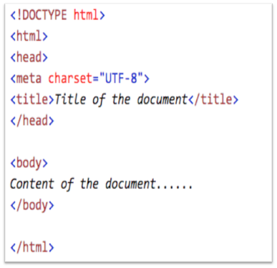

Add your name and this lab information in the HTML page. Include a photo of yourself on this webpage. Open this webpage in a browser (just double-click to open in the default browser) to capture the screenshot of this page in the browser and include the source of this HTML code in your report.

* 1. (2 points) Simple JavaScript.  
     Add the following two lines of JavaScript code in the HTML page within a <script>...</script> tag:

document.write("Content generated from document.write");

document.write("<script>alert('script code is generated within script code');</"+"script>");

Save and open the webpage in a browser to observe: What is the result of the first line of code? Of the second line? Why is the string in the second line not displayed like in the first line? Capture the screenshot to demonstrate this.

* 1. (3 points) Cookies in JavaScript:  
     Add the code below to store/display a piece of cookie.

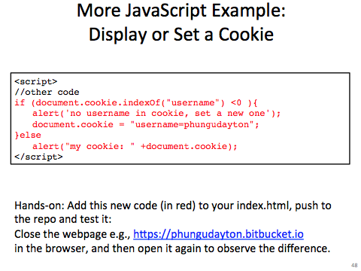

Please change the cookie value accordingly, e.g., username=yourusername. I**f you have opened the webpage previously with this code, you need to clear the cookies in the browser** (In Firefox on SEED VM, click on History -> Clear Recent History -> Clear Now (ensure the Cookies option is selected). You can read this page <https://kb.iu.edu/d/ahic> for other browsers). Open the webpage in a browser to capture the screenshot to include in your report and answer the question: which alert message in the code was displayed in this first trial and why? Refresh the browser to observe the code execution, capture the screenshot to include in your report and answer the question: which alert message in the code was displayed in this second trial and why?   
  
Turn off the browser, and then open the webpage again in that browser in the same way. Which alert message in the code was displayed in this new trial and why? In other words, where are the cookies stored?

* 1. (4 points) Third-party (remote/external) JavaScript:

Add the code below (introduced in Lecture 13, 2/25/2020)

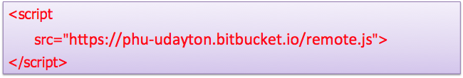

Save your webpage and open it in the browser again. Capture the screenshot to include in your report and answer the following question:  
What is the same-origin policy? Are the cookies protected by the same-origin policy? Why can the remote JavaScript code read the cookie on the webpage?

* 1. (2 points) A Simple clock in JavaScript:   
     Add to the webpage to JavaScript code provided below to display a clock (introduced in Lecture 13).   
     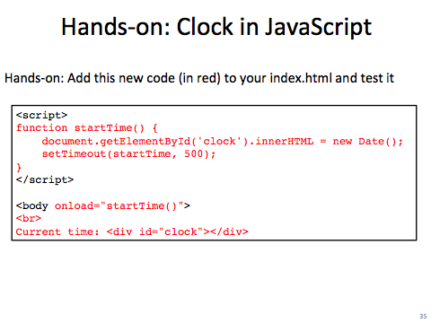  
     Open the webpage in a browser to capture the screenshot to demonstrate this and answer the following question in your report: how does the webpage keep updating the time?
  2. (2 points) Show/hide email in JavaScript:   
     Add the code below that is to display or hide your real email address (you need to change your email address. Include the code in your report and capture 2 screenshots to demonstrate this.

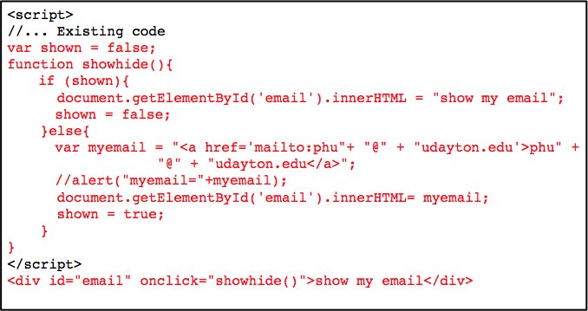

1. Webpage Deployment
   1. (2 points) Deployment on bitbucket.io server

Note: you should already complete this as homework. This is just a piece of reference information. Bitbucket has a cloud service that provides a free web hosting service. You can read their web hosting cloud information here: <https://confluence.atlassian.com/bitbucket/publishing-a-website-on-bitbucket-cloud-221449776.html>

To publish a website using this service, you need to create a public repository on bitbucket.org with the name of bitbucket-username.bitbucket.io, where bitbucket-username is the exact your bitbucket.org account username. Any files you push on this repo will be published on the website with the URL of https://bitbucket-username.bitbucket.io

In this subtask, you need to create such a public repository (if you have not done), clone them to your SEED VM. Copy the index.html file from (a) to this repo and rename it to lab4.html. Push it to the bitbucket and open the corresponding URL https://bitbucket-username.bitbucket.io/lab4.html in your browser to test (if you have created this lab4.html file on your bitbucket repo previously, you can rename it to a different name, e.g., lab4v1.html, to avoid the repo conflict). Capture the screenshot of your webpage https://bitbucket-username.bitbucket.io/lab4.html opened in the browser.   
  
Note that some browsers, for example, Firefox in the SEED VM, will block remote JavaScript that they consider unsafe. To allow the remote script in (a) executed to observe the experiments, you need to allow remote scripts.

* 1. (3 points) Deployment on Apache Web Server

To publish a website on a web server, you need to copy the files to the web server root directory. Each web server has different settings and root directory. For example, the web server on bitbucket.io requires you to push all file on your <accountname>.bitbucket.io on bitbucket.org as we have done in Task 1.b.i.

In this subtask, we do the web publishing on the Apache Web Server that has already installed and run on the SEED VM. The root directory for this web server is located at /var/www/html directory, every file stored in this directory will be accessible at the web address of <http://localhost> (within the VM) or   
http://<IP address> (within our outside the VM). To perform this task, create a new folder lab4 in the web server root folder. As this web server root folder is protected by the root privilege, we have to use sudo to create the new folder:

$ sudo mkdir /var/www/html/lab4

Copy the index.html and the image files in Task 1.a to this folder (please note your repo name is different from me):  
  
$ sudo cp ~/secad-pphung1/labs/lab4/*.* /var/www/html/lab4

Now the webpage should be accessible at <http://localhost/lab4>. Capture the screenshot of the steps and the website on your browser **(2 points)**. See my screenshot for reference.

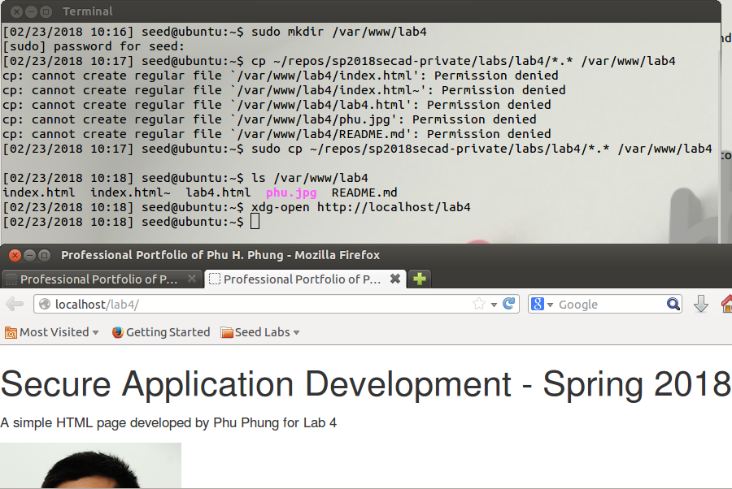

If you have setup the Host-only Network properly in the VM as in Lecture 2, the web server will be also accessible from your host machine (laptop). Use ifconfig to get host-only network IP address, e.g., in my VM, the IP address is 192.168.56.100. Open a browser from your laptop and open this website at http://<the IP-address>/lab4. Capture the screenshot to include in your report (**1 point**). See my screenshot below for reference.

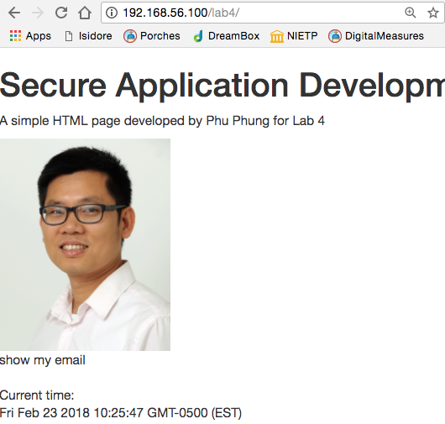

**Task 2 (10 points): Webpage Development with CSS**

In this task, you will do self-study to use Bootstrap CSS template to develop your professional portfolio to publish on https://your-bitbucket-accountname.bitbucket.io (as done in Task 1.b.i).

You must develop a webpage named index.html and push on the repo. Your index.html page must have the full information as a professional profile and additional JavaScript code:

* A clock as in Task 1.a.iii
* Your photo
* Your name
* Your contact information (your email must be displayed using JavaScript as in Task 1.a.iv).
* Your background, e.g., education
* Your experiences and skills

Follow the tutorial here to develop your site using Bootstrap: <https://www.w3schools.com/bootstrap/bootstrap_theme_me.asp>

You should use a free Bootstrap theme on your webpage (you can search and download on the Internet). Your final product is expected to be similar to this webpage: [http://themes.3rdwavemedia.com/demo/developer/tom-najdek](http://themes.3rdwavemedia.com/demo/developer/tom-najdek/)

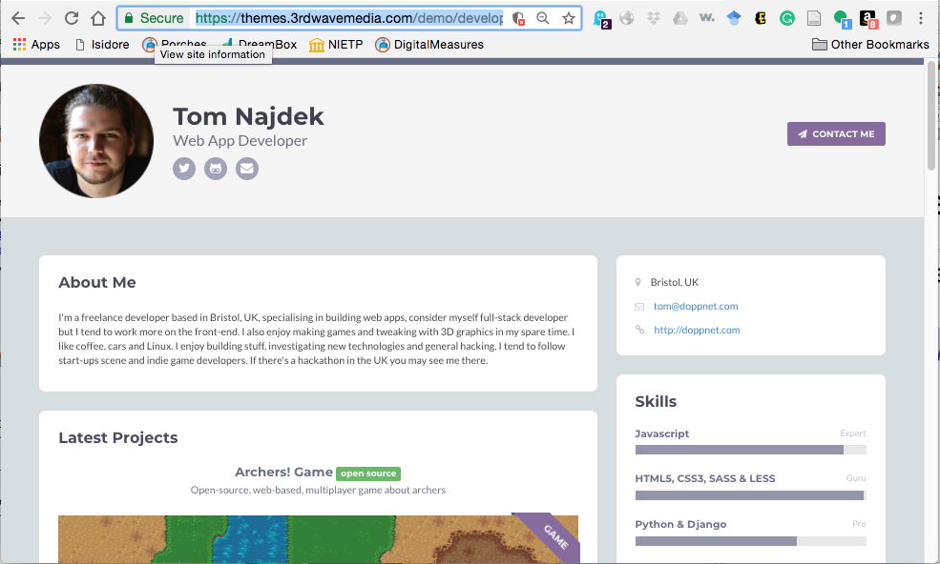

Include the URL of your public website on bitbucket.io in your report and capture the screenshot of the webpage as above (might be incomplete, you can keep updating your profile and skills by the end of this semester). ***I will grade this task by the end of the semester as if I am your potential employer!!!***